**St Peters’ Grand Auction of Promises** 

Bidding form

Please browse our catalogue of promises – there are some amazing lots and a wide variety so we hope you find something that takes your fancy.

There will be a live auction at Rous Lench Village Hall on 16th October 2021. Chilli and garlic bread will be served and the bar will be open. Tickets are £5 each. Please contact Fran on 793651 if you would like tickets.

We will also be taking paper bids in advance. The deadline for paper bids is 14th Oct 2021.

Bidding by paper is really easy – please just complete the slip at the bottom of this sheet with your starting and final bids and either :

* Put this form in Fran’s postbox ( Grafton Barn Rous Lench) by 14th October
* email it to [b.herdman@btinternet.com](mailto:b.herdman@btinternet.com) by 14th October or
* phone Fran on 793651 by 14th October

Name

Address

Contact details

I want to make a paper bid Y/N ( please indicate)

I would like to place a starting bid of £10.00 for Lot no

With incremental rises of £ 2.00 up to a maximum bid of £16.00 - example



( you can bid for as many lots as you like – please just add to the list) -see overleaf

I pledge to pay the above sum if my bid is successful when asked to do so.

If your bid is successful we will bring you a voucher which can be redeemed for the lot whenever you choose. Payment is to be made on receipt of the voucher ( cash or cheque please).

Thank you very much for your support – good luck with your bids!

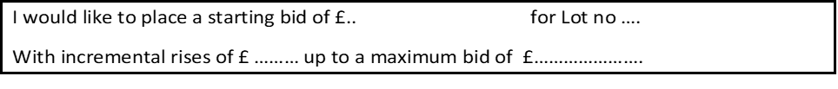







Paper bids:

All bids will be numbered upon receipt, in the event of 2 equal bids the first opened (received) will be the winning bid.

The illustrations in the auction booklet are only a representation of the item that you are bidding for, please be aware the actual item may look different.